**CANDIDATE MANAGEMENT**

1. **Controllers class diagram**

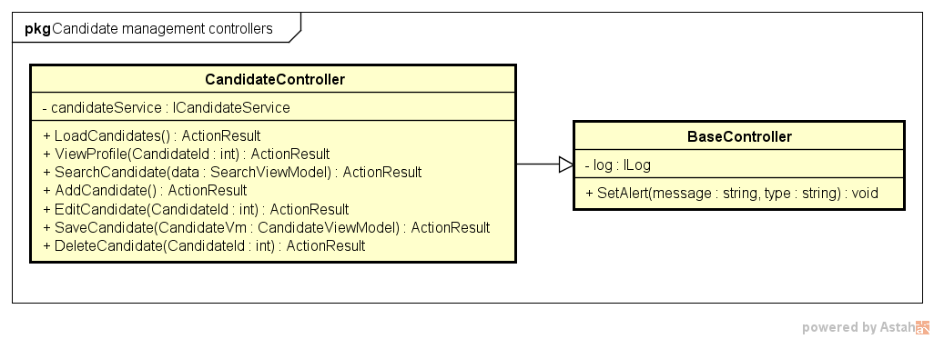

1. **ViewModels class diagram**

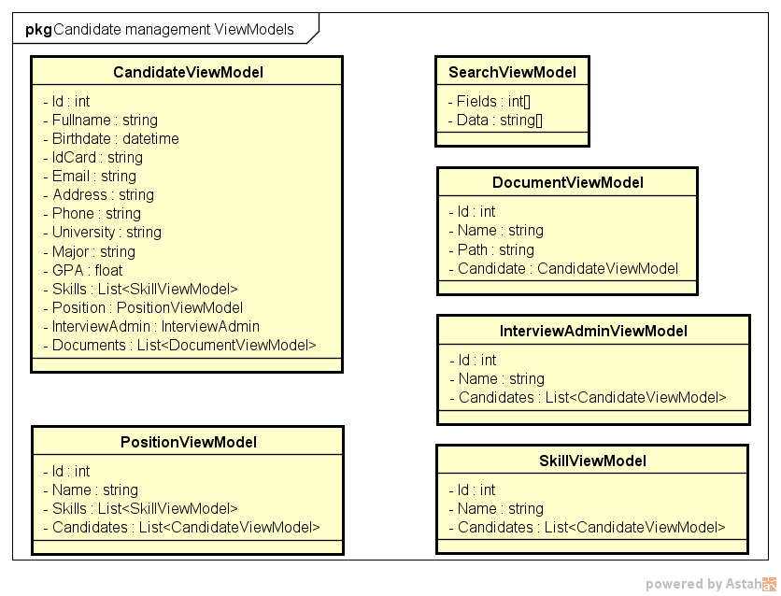

1. **Entities class diagram**

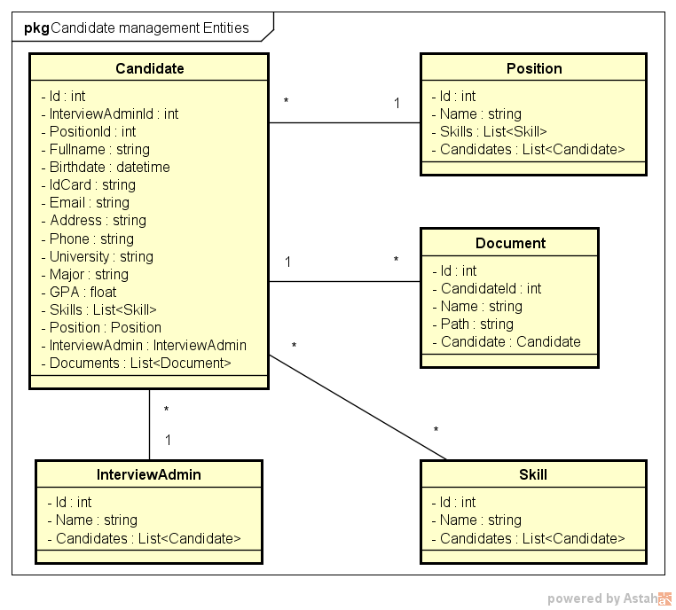

1. **Repositories class diagram**

